1.

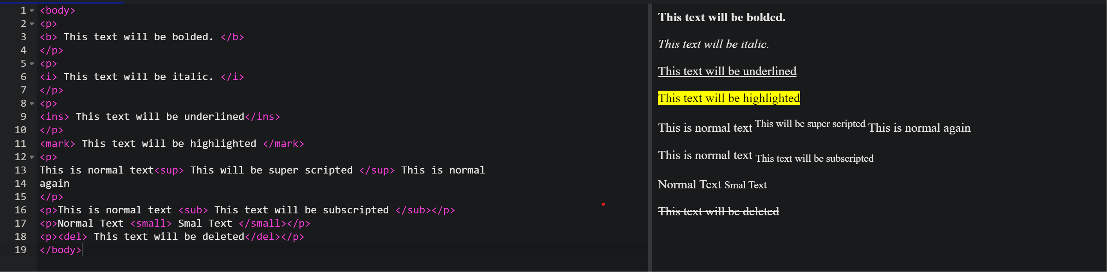

2.

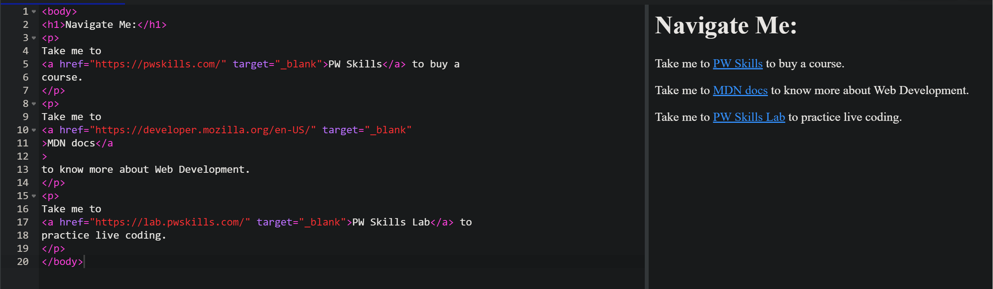

3.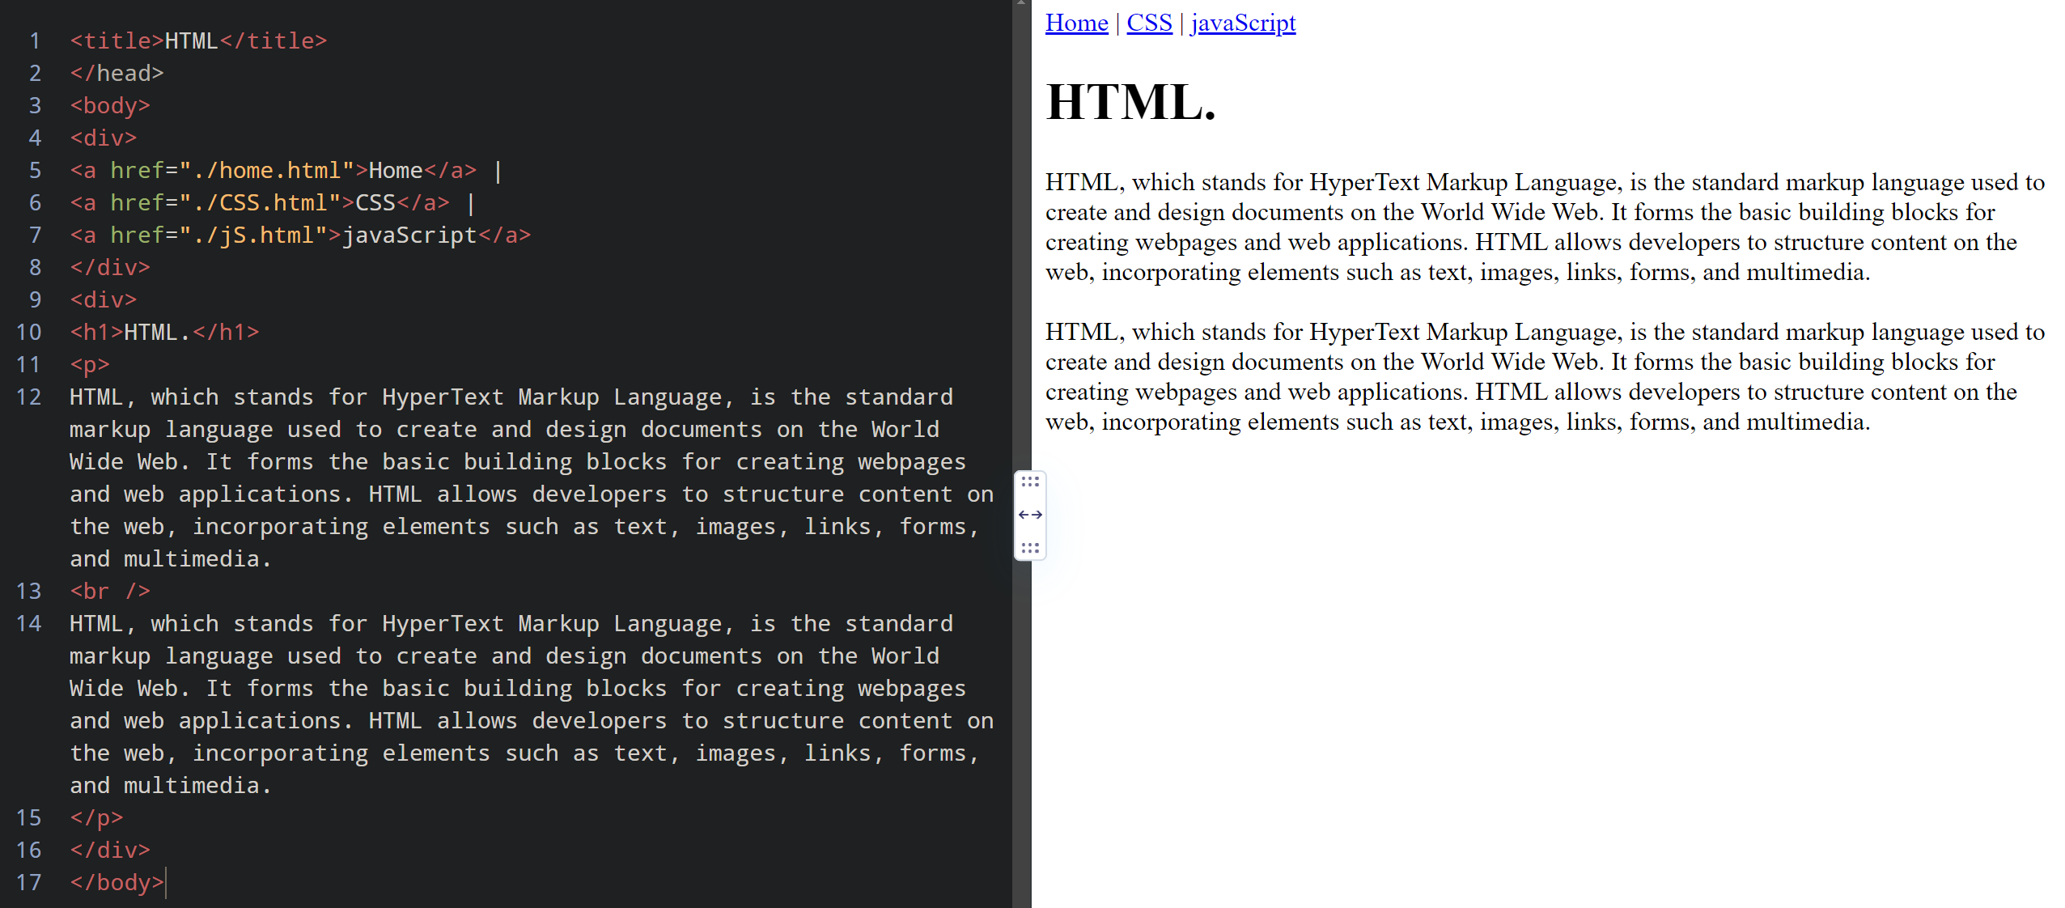

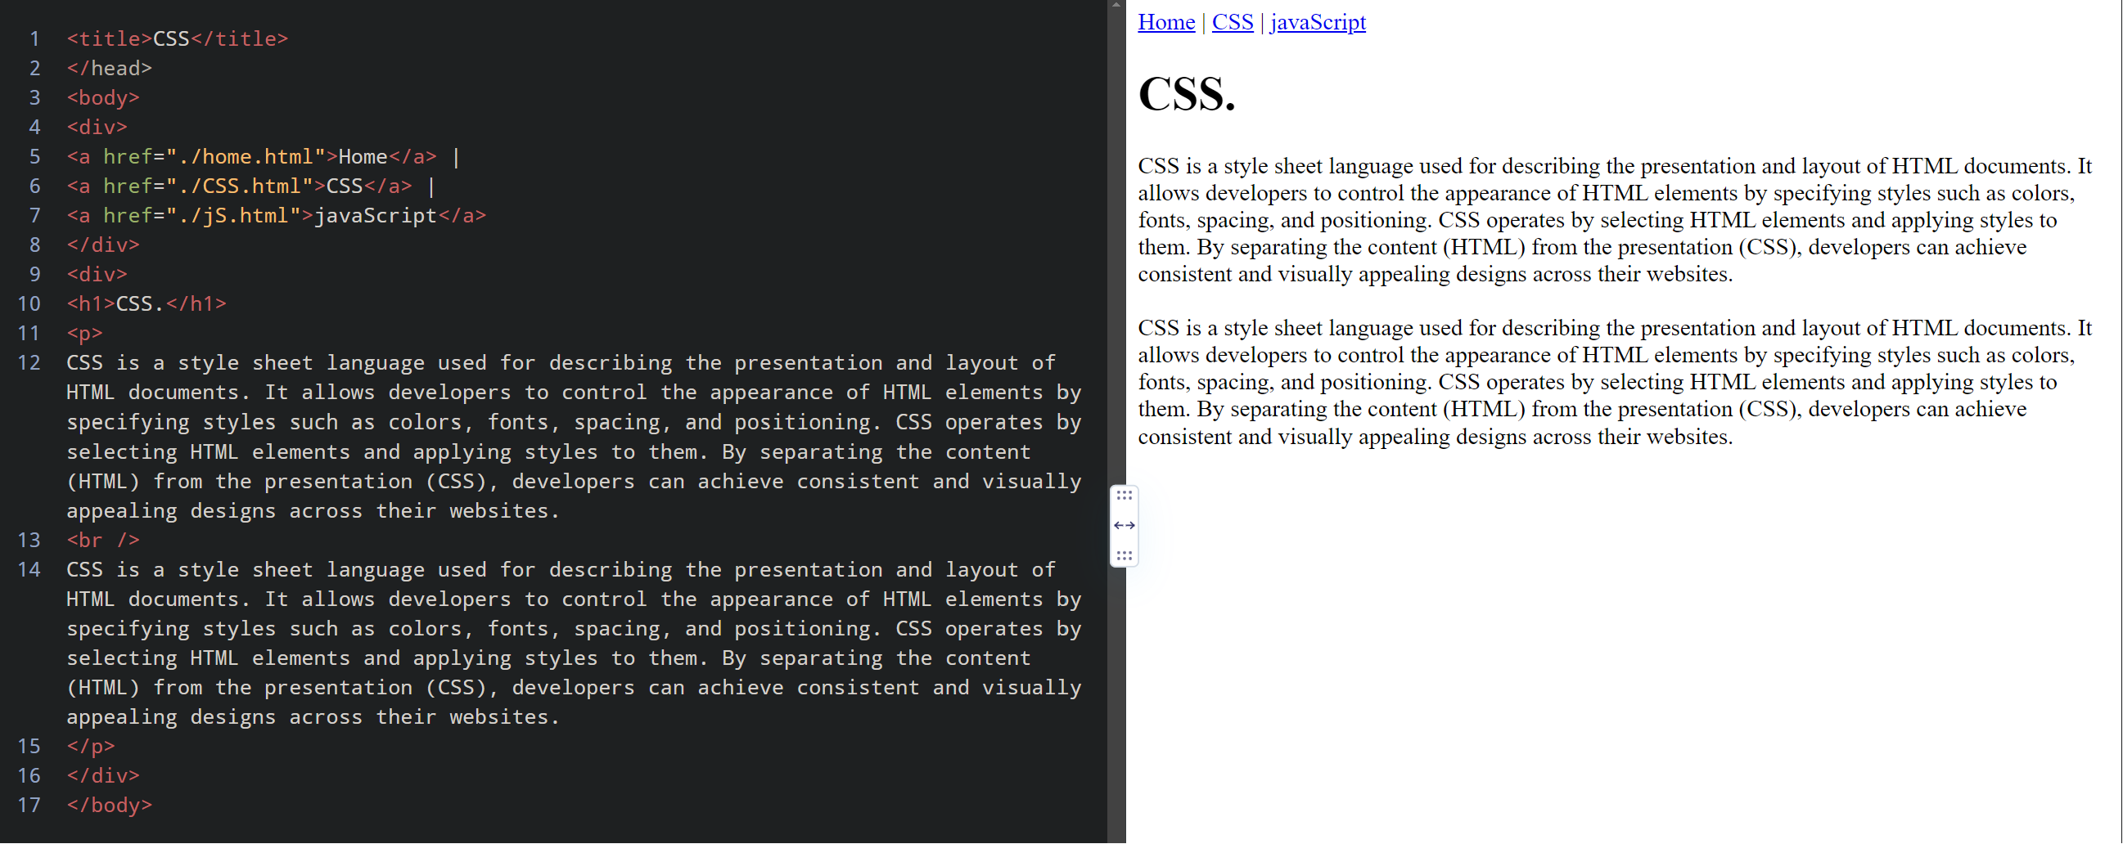

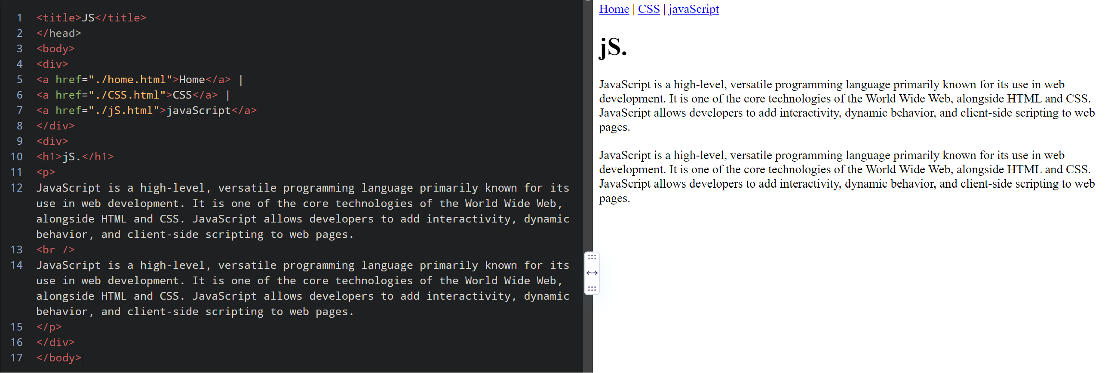

4.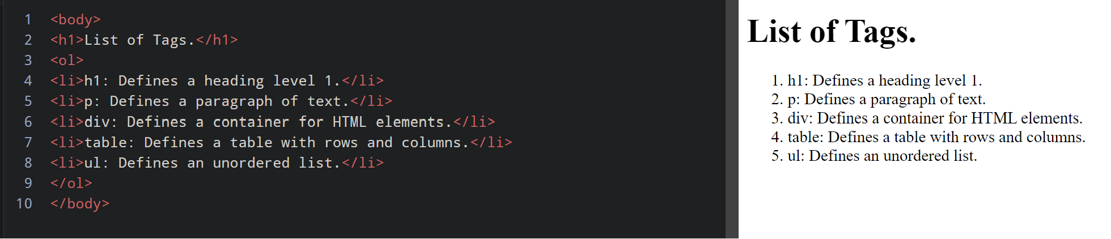

5.

<body>

<h1>Full Stack Web Development Tech Stack:</h1>

<dl>

<dt>HTML</dt>

<dd>

HyperText Markup Language is the standard markup language for creating

web pages and other online documents.

</dd>

<dt>CSS</dt>

<dd>

Cascading Style Sheets is a style sheet language used for describing the

presentation of a document written in HTML or XML.

</dd>

<dt>JavaScript</dt>

<dd>

JavaScript is a programming language used to create interactive effects

within web browsers.

</dd>

<dt>Node.js</dt>

<dd>

Node.js is an open-source, cross-platform, JavaScript runtime

environment that executes JavaScript code outside of a browser.

</dd>

<dt>Express.js</dt>

<dd>

Express.js is a web application framework for Node.js designed for

building web applications and APIs.

</dd>

<dt>MongoDB</dt>

<dd>

MongoDB is a NoSQL document-oriented database program that uses

JSON-like documents with optional schemas.

</dd>

<dt>React.js</dt>

<dd>

React.js is a JavaScript library for building user interfaces or UI

components.

</dd>

</dl>

</body>

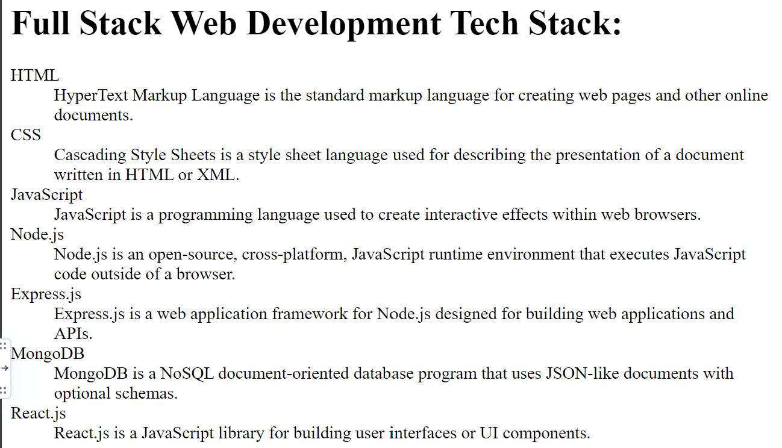

6.

<body>

<ol>

<li>

<h2>HTML</h2>

<table border="1">

<tr>

<th>Primary Use Cases</th>

<th>Key Features/Benefits</th>

</tr>

<tr>

<td>Building the structure of web pages</td>

<td>

<ul>

<li>Simple and easy to learn</li>

<li>Compatible with all web browsers</li>

<li>Allows for semantic markup</li>

</ul>

</td>

</tr>

</table>

</li>

<li>

<h2>CSS</h2>

<table border="1">

<tr>

<th>Primary Use Cases</th>

<th>Key Features/Benefits</th>

</tr>

<tr>

<td>Styling and layout of web pages</td>

<td>

<ul>

<li>Allows for separation of content and presentation</li>

<li>Enables responsive design</li>

<li>Offers a wide range of styling options</li>

</ul>

</td>

</tr>

</table>

</li>

<li>

<h2>JavaScript</h2>

<table border="1">

<tr>

<th>Primary Use Cases</th>

<th>Key Features/Benefits</th>

</tr>

<tr>

<td>Adding interactivity and functionality to web pages</td>

<td>

<ul>

<li>Can manipulate and modify web page content in real-time</li>

<li>

Offers a wide range of functionality through libraries and

frameworks

</li>

<li>Allows for server-side scripting with Node.js</li>

</ul>

</td>

</tr>

</table>

</li>

</ol>

</body>

